Bash scripting for programmers

Fundamentals of Unix and Bash to automate common tasks for ETL or app deployment

Sprint 5
Data & Analytics

Bash scripting for programmers

Table of Contents

Bash scripting for programmers 2
Introduction 5
Assessment 5
History and modern use cases 6
Why Unix? 6
History 6
Design Goals 6
Present use cases 8
Activity 9
‘Everything in Unix is either a file or a process’ 10
Getting Help 10
Activity 10
Navigating the Unix file system 14
Unix file system facts: 14
File system demonstration 15
Current and Home directories 15
Activity 15
Relative and Absolute paths 18
Activity 18
Viewing the file system 20
Activity 20
Modifying the file system 23
Activity 23
Introducing wildcards – asterix and ? 24
Activity 24
Redirection to create a file / persist data 26
Activity 26
Activity 27
Activity 28
Using data 30
Using data in the file system and streams 30
Locate files in the filesystem or search data within files 30
Activity 30
Pipes 32
Activity 32
grep command 34
Activity 34
Using Commands 36
Commands for basics 36
Activity 36
Activity 37
Text output handling 40
Activity 40
Activity 41
Workflow automation 44
Commands are designed to use together 44
Using results with ‘action’ arguments 44
Activity 44
Using Conditionals for actions 46
Activity 46
Three Types of Conditions in Bash 47
Activity 47
Combining Conditions 48
Activity 48
Exit Status for Conditional Execution and Flow Control 48
Activity 49
Flow control mechanisms 51
Conditionals 51
Loops 51
Modifying flow to handle errors etc 51
Automating Bash commands 52
Bash script facts 52
Scripting with examples 54
Bash script – Example 1 54
Activity 55
Example 2 – operator inputs 58
Example 3 – reading files 59
3 versions of similar code to explore and develop 60
Version 1 61
Version 2 62
Version 3 63
Process management 65
Basic process management 65
Managing processes demonstration 66
Activity 66
Job management 68
Activity 68
Other useful commands to research 69
Activity 69
Final Exercise 71
Create a Bash script pair and log activity 71
Activity 71

Introduction

Bash scripting is a cornerstone of Unix and Linux systems, providing a powerful way to automate tasks, manage files, process data, and streamline workflows. This module will introduce the fundamentals of Unix and Bash, with the goal of automating common tasks for ETL or application deployment.

As Unix has been an industry standard OS for a long time with many uses there are many more concepts, commands, and syntax that will not be covered in this module. Unix comes in many varieties and there are also Unix-like operating systems like Linux, this material aims to apply to most.

It is expected that you will bring your current experiences with home and university computing, access to online systems like online commerce, gaming, and entertainment to any group discussions where the ideas may be relevant.

These are the topics that will be introduced.

- Unix history and modern use cases
- Navigating the Unix file system
- Managing files and directories with permissions
- Parsing and processing data streams
- Writing Bash scripts using control structures and runtime arguments
- Hands-on examples for learning and practice
- Basic process management
Demostrate 2 phases for the project

Assessment

Assessment of this module is achieved by successful submission of:

- Completed workbook
- This workbook needs to be completed accurately and submitted by due date
- All answers provided can be defended during a professional discussion
- Project
  - There is a 3-phase project submitted during Sprint 5
  - All 3 phases are Bash scripts
  - Phases 2 and 3 include non-Bash commands as well that are covered later

History and modern use cases

Why Unix?

History
- The early development of UNIX was in the late 1960s and early 1970s at Bell Labs and universities
- Foundational goals shaped by the needs and aspirations of its creators especially Ken Thompson, Dennis Ritchie, and others
- Goals reflect the desire to create practical, flexible, and efficient operating system

Design Goals

Portability across hardware

- Make the operating system adaptable to different types of computer hardware like CPUs
- Much of UNIX was written in C which provides a higher level of abstraction compared to assembly language which is specific to the instruction set architecture of a CPU-family (e.g., x86, ARM, RISC-V)

Simplicity and elegance

- Create a system that was simple, understandable, and easy to use and develop (for the available hardware)
- A minimalist kernel design for benefits like modularity, extensibility, optimised performance
- A CLI with a small set of commands and utilities that could be combined in powerful ways using pipes and redirection

Time-sharing support

- Sharing resources like CPU and memory efficiently
- This was a response to the growing need for systems in academic and research settings

File system innovation

- Flexibility and simplicity in file management
- The UNIX file system introduced features like:
  - A uniform interface for accessing devices and files
  - Hierarchical directories
  - Support for symbolic links and special files

Extensibility

- By providing a set of simple, general-purpose tools and encouraging modularity, UNIX enabled developers to build custom solutions without altering the underlying OS

Interactivity

- Interactive computing with a command-line shell that provided direct, efficient user interaction compared with batch execution
- The shell became a powerful tool for scripting and process management

Collaboration and accessibility

- UNIX was designed to run on relatively modest hardware and provided an accessible platform for experimentation and development in academic and research institutions

Cost-effectiveness

- ‘More bang for the buck’
- Design was influenced by the limited resources available at Bell Labs after AT&T withdrew from the Multics project
- This led to a focus on efficiency and practicality

The result

- UNIX was a groundbreaking operating system, laying the foundation for many modern OS architectures and philosophies
- Its influence persists with Linux, macOS, and even Windows

Present use cases

Unix and its derivatives (e.g., Linux, macOS) remain highly relevant in modern computing due to their reliability, versatility, and performance

Here are the top 5 use cases for Unix in modern computing:

Servers and web hosting

- Unix-based systems power more servers in the client/server model globally as: web servers, database servers, and application servers
- Tools like Apache, Nginx, and MySQL are optimised for Unix systems

Software development

- Unix desktops are preferred by software developers, especially for open-source and cross-platform development
- POSIX compliance ensures compatibility across platforms

High-performance computing (HPC) and scientific research

- Supercomputers and research labs prefer Unix for computationally intensive tasks
- Climate modelling, genomic research, and astrophysics simulations

Embedded systems and IoT

- Many embedded systems and Internet of Things (IoT) devices like Raspberry Pi’s run Linux
- Lightweight kernel and flexibility to customise for specific hardware like Routers, smart TVs, automotive systems, and industrial control devices

Cybersecurity

- Foundational for cybersecurity because of strong permission and user management model
- Widely used in penetration testing and ethical hacking with distributions like Kali Linux

Activity

Research Questions:

What does GNU stand for? Now, what does GNU stand for?
GNU us a recursive acronym for “GNU’s Not Unix.”
It’s intentionally self-referential — a bit of classic hacker humor — and it reflects the project’s goal: to create a Unix-like operating system that is free software but not Unix itself.
If you’re curious, I can also explain why recursive acronyms are a tradition in the free-software world or how GNU relates to Linux.

Are you using a Unix like personal computer to get your work done?
I am using an operating system that is not Unix-like. It has its own architecture and its own design.

If not, why?
It is not very praticle

What OS and version are you using?
Microsoft Windows 11, OS Build 26200.7840

‘Everything in Unix is either a file or a process’

- Files: All persisted data, including regular files, devices, and inter-process communication constructs, identified by a path (directories)
- Processes: Are running instances of programs, each identified by a unique process ID (PID)

This is for simplicity, modularity, extensibility with a consistent interface.

There are many resources available to learn more. The primary source of information is known as the ‘MAN pages’ which is an abbreviation of ‘manual’. It is available in Bash session via the command ‘man’ or web-search.

Getting Help

Help on concepts, commands, and syntax is available from the following sources:

- Via Bash session: ‘man’ online MAN pages to find a command like ‘echo’
- Via Bash session: ‘–– help’ syntax for any command (with minus,minus,help)
- Use your favourite search engine to search for ‘bash echo’ or similar
- Online reference: https://www.gnu.org/software/bash/manual/bash.html

Activity

Try the following commands in a Bash session:

 | Command | Notes
 | Man bash | The online help system:  - Try to navigate  - Read a little about Bash now  - Read the help on how to navigate (press h)  - Find out how to search within the man pages  - Use ‘q’ to quit  What does pressing ‘f’ key do?  Command not found  What does pressing ‘b’ key do?  Command not found
 | man echo | Specific help on the ‘echo’ command
 | echo --help | Online syntax help

Try the following from your web browser:

Use a search engine with search terms like: unix, bash, help, echo

Try similar search terms to find more than one website with the man pages online

Is it simple to search for Bash references online?

Yes It is simple to search for Bash references online.
Try this https://www.gnu.org/software/bash/manual/bash.html

What is this?

This is a website describing the features that are available in the Bash shell. It gives an overview of table of contents

Use gnu.org and the URL in the last question to research these terms.
Provide a definition in your own words:

What is a shell?
A shell is a macro processor that executes commands. The term macro processor means functionality where text and symbold are expanded to create larger expressions.

What is a builtin command?
The shell execuretes the command directly, without invoking another program. They are contained within the shell itself.

What is a shell script?
shell script is a text file containing shell commands

List some differences between what a CLI and GUI for an OS.
A GUI lets users interact with the operating system using:
- Windows
- Icons
- Buttons
- Menus
- Mouse/touch input
Examples
- Windows desktop
- File Explorer
- Settings app
- macOS Finder
Characteristics
- Visual and user-friendly
- Easy for beginners
- Uses mouse + keyboard
- Slower for repetitive tasks
- Requires more system resources

A CLI lets users interact with the OS by typing text commands.
Examples
- Command Prompt (cmd)
- PowerShell
- Linux Terminal
- macOS Terminal
Characteristics
- Text-based interface
- Requires memorising commands
- Very fast for advanced users
- Excellent for automation & scripting
- Uses fewer system resources

Can you have apps that have only a CLI or only GUI? What are the issues
A GUI allows users to interact with the OS visually using icons and windows, making it intuitive and beginner-friendly. A CLI requires typed commands but offers greater speed, control, and automation capabilities, especially for advanced users.

Definitions:

Control operators

Control operators are special symbols used in a command-line shell to control how commands are executed.

They determine:
- Order of execution
- Conditional execution
- Background execution
- Command separation
;, &, &&, `

Metacharacters
Metacharacters are special characters that have a specific meaning in the shell and are not treated as normal text.
hey are used for:
- Redirection
- Wildcards
- Command substitution
- Quoting

*, ? , >, <, $, “’
e.g ls*.txt
* is a metacharacter matching all .txt files

Names
Names are identifiers used to represent variables, functions, commands, or files.
Rules (in most shells):
- Must start with a letter or underscore
- Can contain letters, numbers, underscores
- No spaces

My_variable

Reserved words

Reserved words are keywords that have special meaning in the shell language and cannot be used as variable names. They are part of shell syntax
If , then, else, fi, while etc.

Navigating the Unix file system

Unix file system facts:

Data or instructions (code): Data and instructions are stored in binary formats due to requirements of computers being made from integrated circuits that use electricity, which can cause issues during power loss or crashes.
Files and directories: Data can be persisted between processes or when the computer is shut down as files in a file system, and directories act as logical containers to organise files.
Hierarchical structure: The file system follows a tree structure, with ‘/’ as the root and subdirectories branching below.
Path representation: The location of a file or directory in the file system is called its path. Paths can be absolute (starting from ‘/’) or relative (starting from the current directory)
Current directory: Users interact with Unix systems through environments called ‘shells’ which provide a user interface to the OS; Bash is a popular example. One service provided by Bash is a current pointer in the tree structure to simplify file system references.
Case sensitivity: File and directory names are case-sensitive (e.g., file.txt and File.txt are distinct).
File system permissions: Permissions (read, write, execute) control access for the owner, group, and others, ensuring security in multi-user environments.
Special files: There are different type of files including regular files, device files, and symbolic links (pointing to files or directories) or hard links (alternative names for file content)
Metadata: A file system index store metadata (e.g., size, permissions, timestamps) that the file system uses to manage operations efficiently.

File system demonstration

- This should be an exploration of the file system and relevant commands to access and describe it.
- The commands are introduced while being used, further commands will be introduced later.
- There are lots of alternative commands or options that can be used in some cases.
- The full list of Unix commands and the syntaxes for use will not be covered but are available from many sources.

Current and Home directories

- REMINDER: Bash is there to provide a human interface for Unix users by making things easier.
- Having a pointer into the file system makes ad-hoc file operations EASIER.

Activity

Try the following commands in a Bash session:

 | Command | Notes
 | pwd | Read what is returned and identify:  What is the directory name under root?  /home/fdmuser  What is the current (present) working directory?  /home/fdmuser
 | cd / | - Change to the root directory using the absolute path  - Confirm that it works
 | pwd | Confirm that it shows the root ‘/’  Yes
 | dir | Make a note of a few dir names found under root
 | cd /home/fdmuser | This is a user home directory for the user account ‘fdmuser’
 | pwd | Confirm that it shows /home/fdmuser  Yes /home/fdmuser
 | cd / | Change your pwd to the root
 | pwd | Confirm the current directory
 | cd ~ | Use the tilda key as a shortcut to home  /home/fdmuser
 | pwd | Confirm the new current directory  /home/fdmuser
Why is it useful to have your own home dir in a multi-user environment?

A home directory in a multi-user environment allows each user to store their own files and settings securely without interfering with others. It ensures privacy, organisation, and proper access control on a shared system. For example, on a Linux system, user Aakansha may have /home/aakansha, where only she can access her documents and configuration files, while other users cannot modify them without permission.

Why is tilda useful?

Tilda (~) is useful because it represents a user’s home directory in a command-line environment, making file navigation quicker and simpler. Instead of typing the full path, you can just use (~).

Relative and Absolute paths

- Another useful symbol apart from tilda is ‘dot dot’ which stands for ‘Go back to the previous directory’.
- In most cases absolute paths should be use when coding.
- Relative paths are usually shorter and have more use with ad-hoc commands.
- An alias like tilda for the home directory is not great for scripts because it is easy to misread but is perfect at the command prompt.

Activity

Try the following commands in a Bash session:

 | Command | Notes
 | cd ~ | Confirm that your Bash session has a pwd of ‘/home’  Yes  Cd ~ then pwd to check  NB: Commonly referred to as being ‘in the home dir’
 | cd .. | NB: This is commonly called ‘CD dot dot’  The characters typed in are:  c,d,<space bar>,<full stop>,<full stop>  /home$
 | pwd | Make sure you are in the ‘home dir’  /home  NB: the directory is called <forward slash> home  This is not the same thing as your home
 | cd .. | CD dot dot again
 | pwd | Confirm that you are in /  NB: this directory is called root
The command ‘cd ..’ uses a relative path.
How does the start of a relative path differ from an absolute path?

 | cd home | Is that a relative path?
 | cd <login.name> | Is that a relative path?
What is the difference between starting a relative path with ‘dot dot’ vs a directory name (refer to the direct in relation to root) ?

An absolute path always starts from the root of the file system:
On macOS/Linux, it’s simply /

A relative path starts from your current working directory, not from the root.
Key trait: it never starts with a drive letter or a leading slash.
Instead, it uses the current folder as the reference point.
. -> current directory
.. -> parent directory
Foldername -> a subfolder inside the current directoy
Cd .. this means go up one folder from where I am right now

 | cd no_directory | What happens when changing pwd using a relative path that does not exist?  -bash: cd: no_directory: No such file or directory
 | cd /no_directory | This time use the ‘/’ as prefix to make an absolute path  Did it work the second time as an absolute path?  /no_directory: No such file or directory
What do you have to specify in a cd command for it to work?
You have to give a path that actually exists.
Cd will only succeed if the directory exists and you have permission to access it.
It doesn’t matter whether the path is:
Relative(cd foldername, cd ..)
Absolute(cd /usr/local/bin)

Viewing the file system

- Commands like ‘ls’, ‘find’, ‘tree’ are used to read or search the index and metadata of the file system.
- Other commands are used to read or search the data: ‘cat’, ‘more’, ‘less’, ‘grep’.

Activity

Try the following commands in a Bash session:

 | Command | Notes
 | cd ~ | cd to your home directory using tilda alias  We usually start from the home dir because we have the most permission to do things there.
 | ls | - ‘ls’ is used a lot, often without options and arguments  - If an option or argument is not provided then default values are used
What is the default directory that ls displays if no argument is provided?

Documents derby.log metastore_db stocks workbook_data.tar

 | ls /home | ls of the directory named /home  This is not the same thing as a home directory!  It can be used with absolute paths  fdmuser fdmuser2
 | ls .. | ls dot dot  It can be used with relative paths  fdmuser fdmuser2
 | ls /etc /var /home | ls with more than one directory argument  - It can be used with multiple arguments  - NB: Unix style commands usually take multiple arguments  ls /etc /var /home  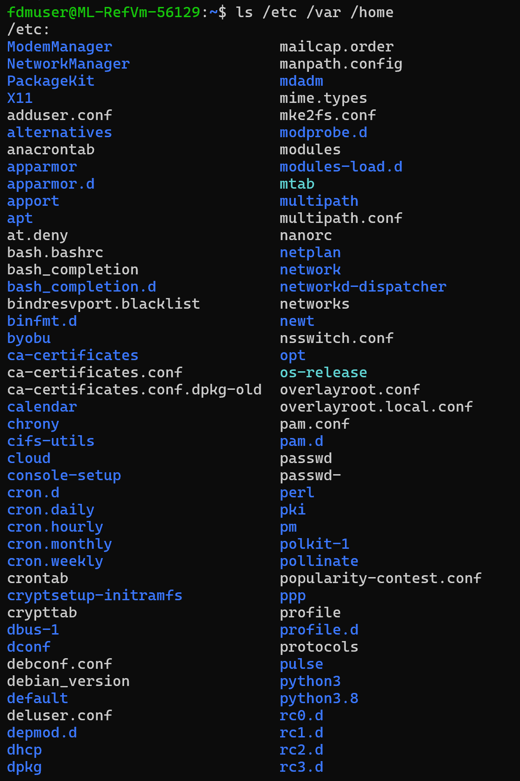 …..  “List the contents of /etc, then list the contents of /var, then list the contents of /home.”
 | ls -l / | ls of root with minus l argument  Find out what this does  “Show me a detailed list of everything inside the root directory.”  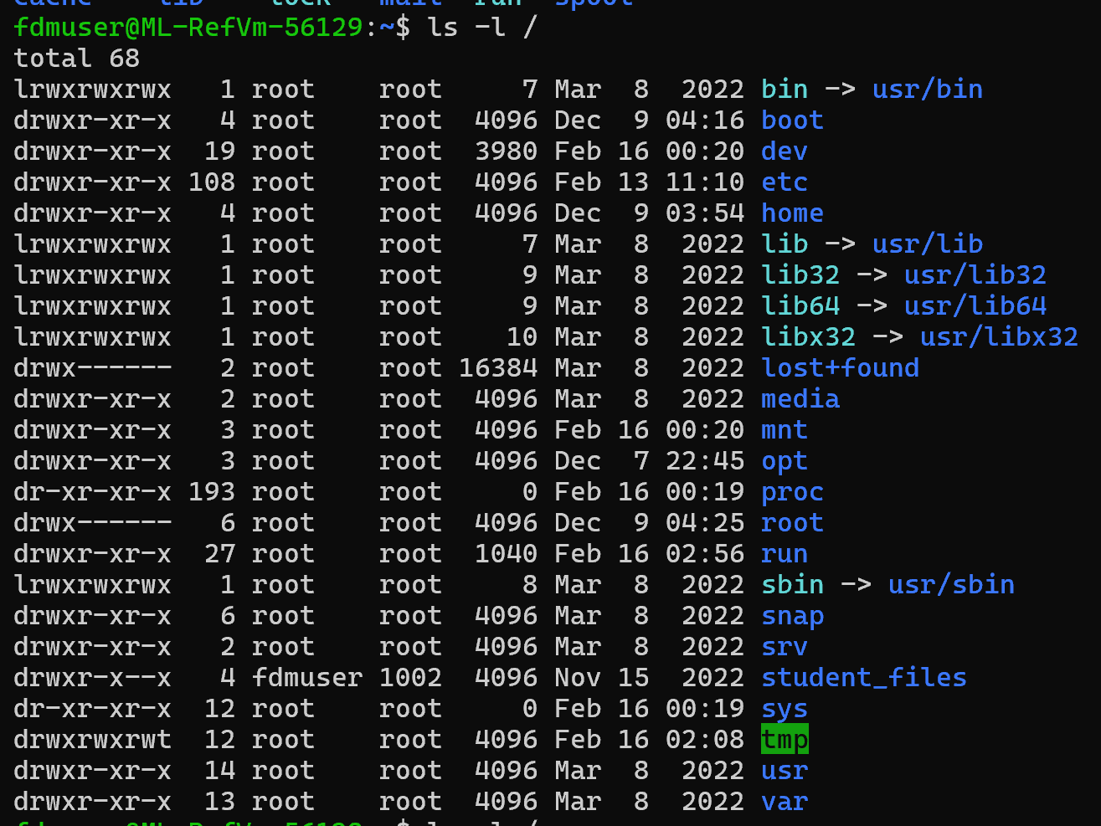  NB: This is the way to check file system permissions
 | ls -a | ls with minus a argument  Find out what this does  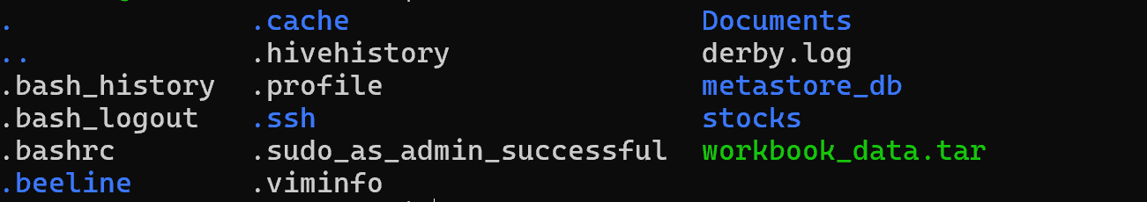  It lists files and directories the -a option means: show all files, including hidden ones  “lists everything, even hidden files.”
- How are files hidden in the file system?

A file is hidden simply by starting its name with a dot(.).
The idea is to keep configuration files and system settings out of your way so that:
- your home directory looks clean
- you don’t accidentally modify important config files
- tools can store settings without cluttering your workspace

- What prefix is used?
(.)

 | ls ~ -a -l | ls with minus a and minus l arguments  Note the result  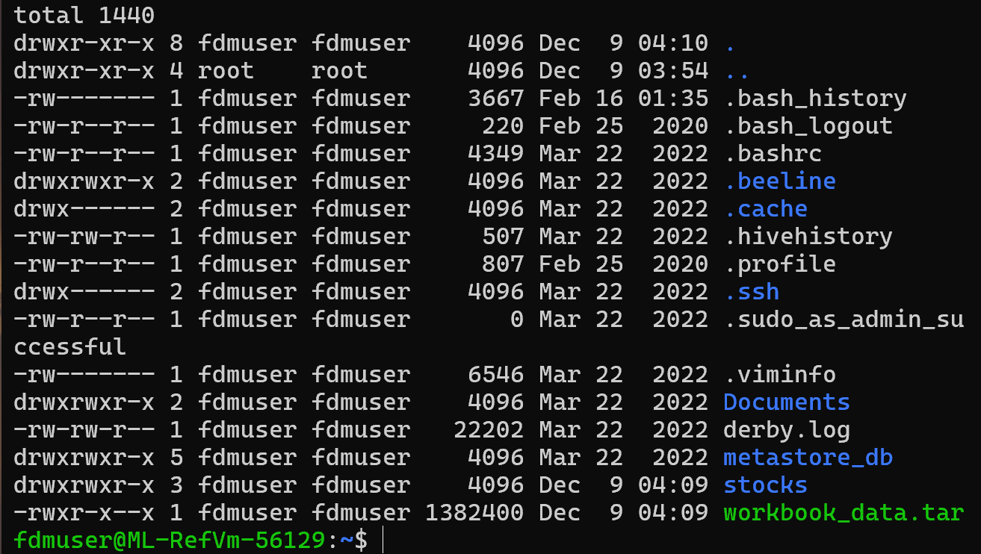  ls  Lists files and directories.  ~  Represents your home directory (e.g., /home/fdmuser).  -a  Shows all files, including hidden files (those starting with a dot, like .bashrc, .ssh, etc.).  -l  Shows details in long listing format, including:  - File type (first character)  - Permissions  - Number of links  - Owner  - Group  - File size  - Last modified date/time  - Name  Breaks down as:  - d → directory  - rwxr-xr-x → permissions  - 2 → link count  - fdmuser → owner  - fdmuser → group  - 4096 → size  - Dec 9 04:10 → last modified  - Documents → name  Your home directory contains:  - Hidden config files (.bashrc, .profile, .ssh/)  - Application data directories (.cache, .beeline)  - A tar archive: workbook_data.tar  - Projects or personal folders (stocks, Documents)
 | ls ~ -al | ls of home directory with minus al arguments together  - This is the same result  - Also ‘ls ~ -la’  Options in Unix commands are usually not positional and can share the ‘-‘  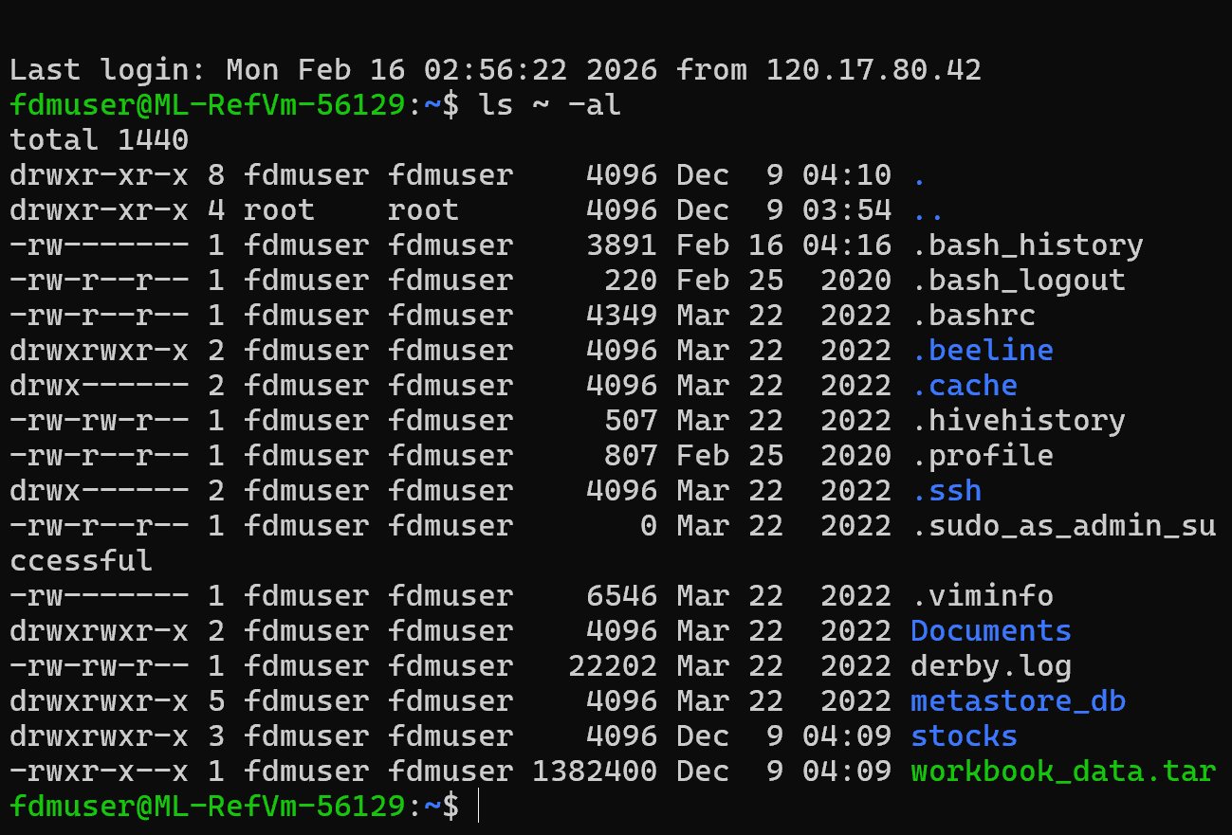  The structure is:  - ls → list files  - ~ → your home directory  - -la → flags:  - -l → long format  - -a → show all (including hidden files)  So the full command means:  👉 List ALL files in the home directory (~) in long format  Total 1440 is the number of blocks used by the file in that directory.
 | ls /student_files | - Explore several ‘ls’ options individually and together  - Note down some examples tried  This lists all files and directories inside the folder: /student_files  Directories (blue)  - day1  - day2  Files (green)  - awkPasswd  - broker_exchange.dat  - brokers.dat  - companies.dat  - currency.dat  - passwd  - places.dat  - sedAndAwkFile  - shareHolders.dat  - shares.dat  - stockExchanges.dat  - trades.dat  - transactionType.dat  - uniqFile  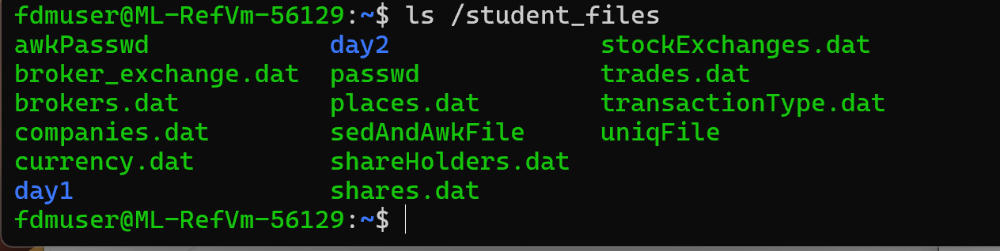
 | tree /student_files | Other commands also can be used  prints a visual directory tree of everything inside /student_files, showing:  - which items are directories  - which items are files  - the hierarchy (what is inside day1, inside day2, etc.)  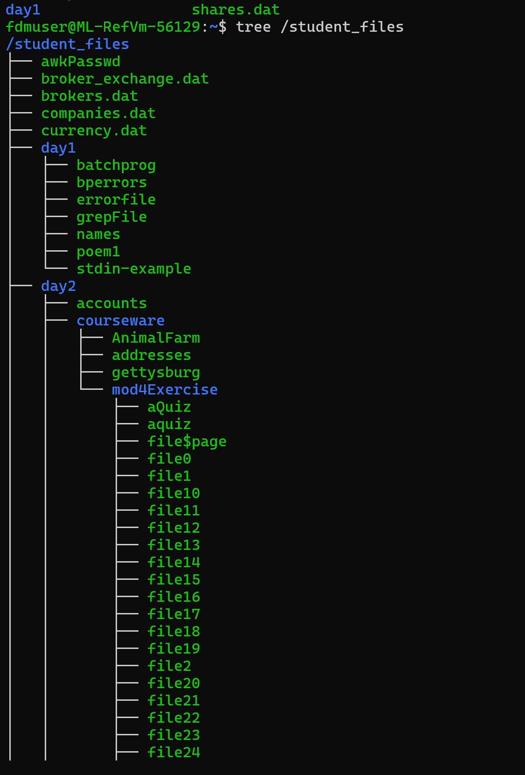  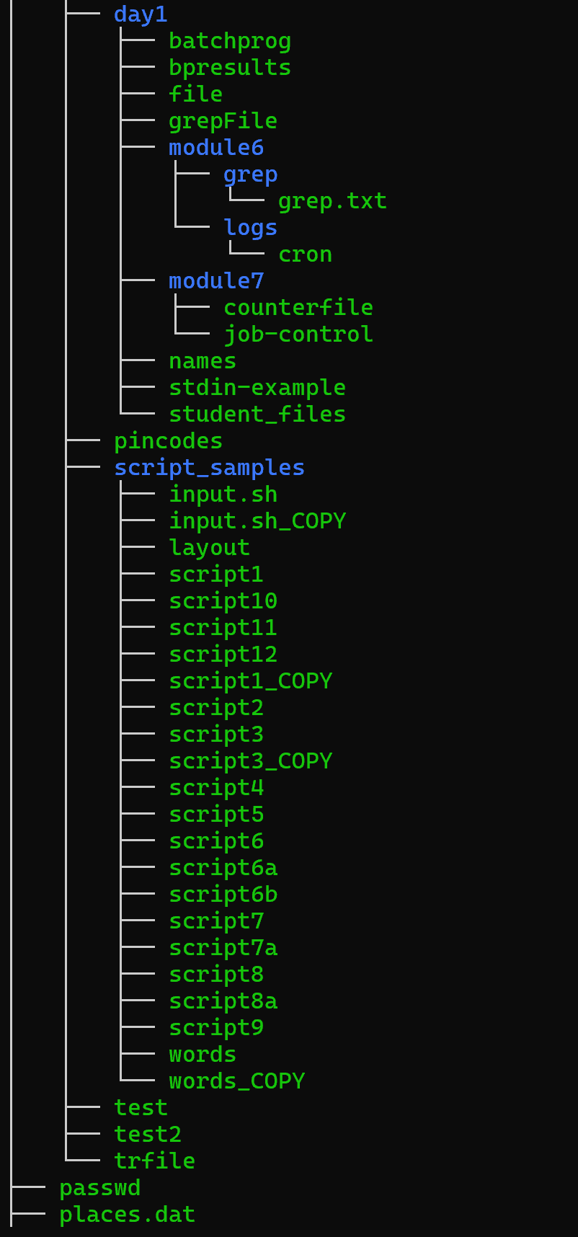  
 | tree –-help | What else can it be used for?  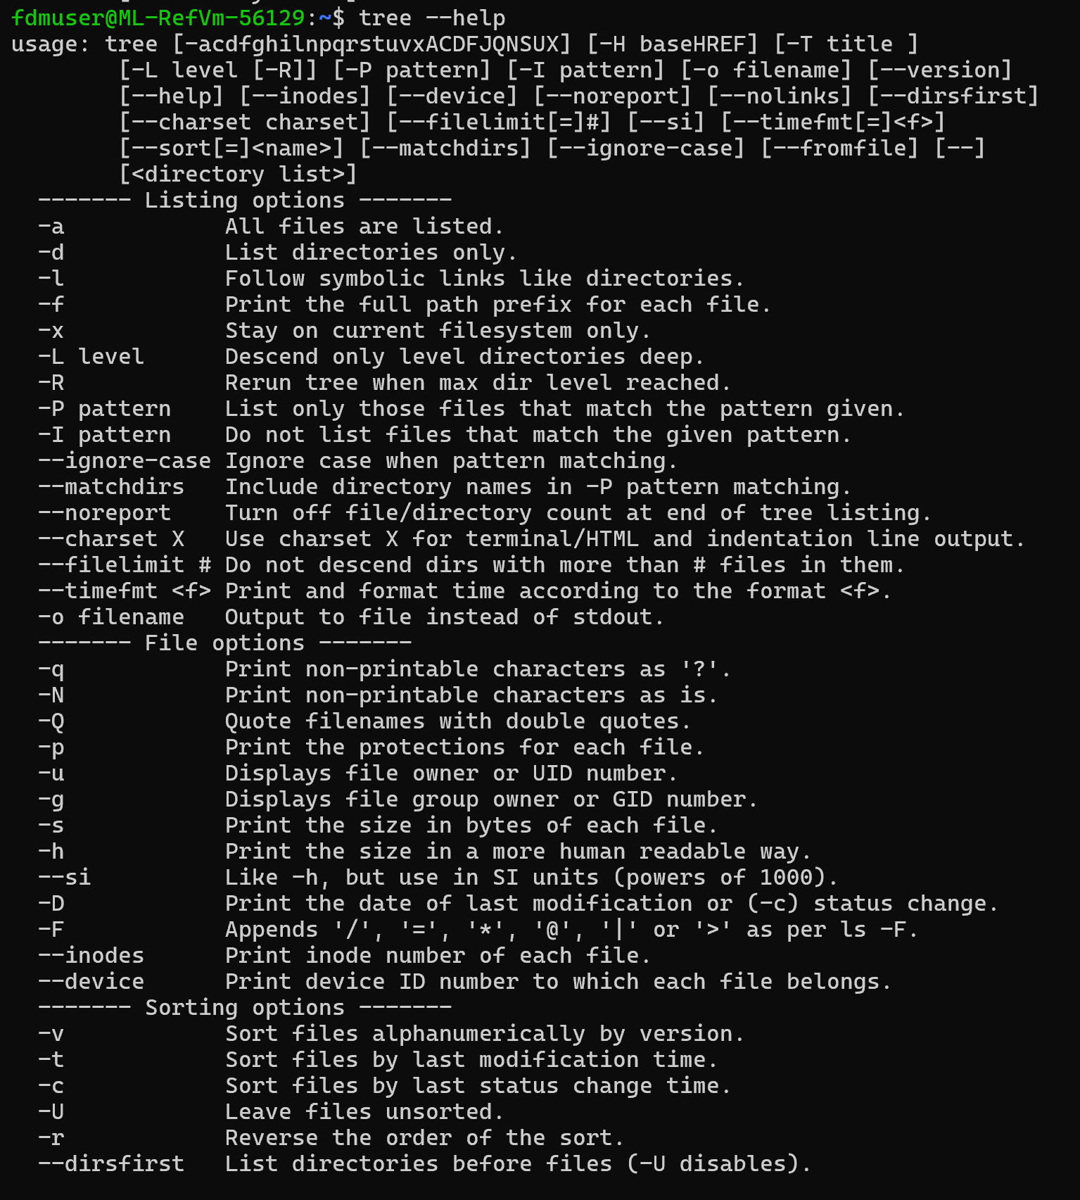  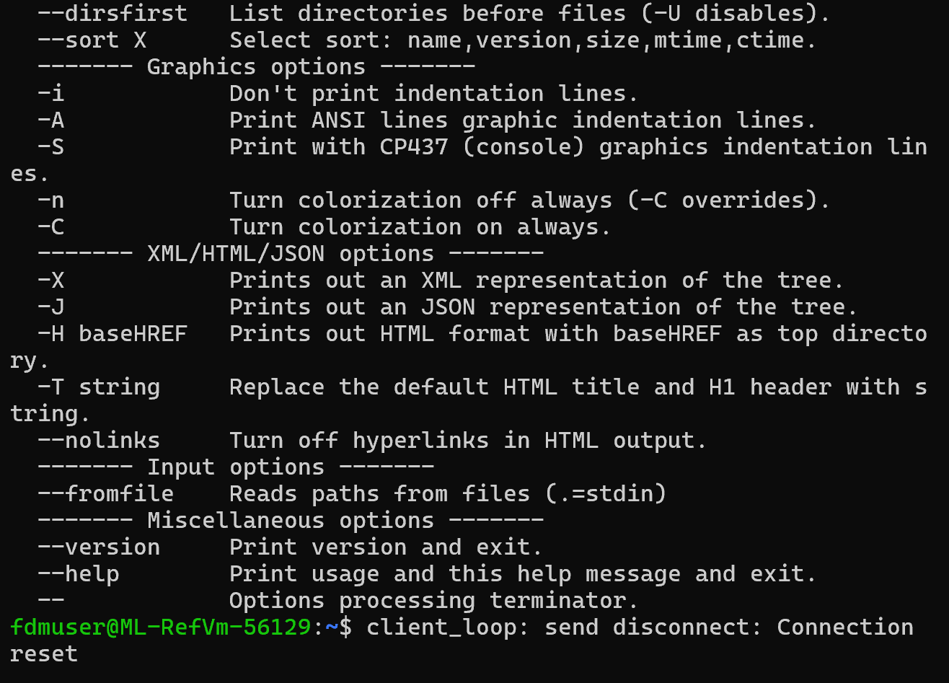

Modifying the file system

- Consultants should work in their own home because of file system permissions.

Activity

Try the following commands in a Bash session:

 | Command | Notes
 | cd ~ | - Starting in home  - This is a normal place to start
 | mkdir new_directory | Make a new sub-directory under home
 | cd new_directory | Change current directory to new_directory  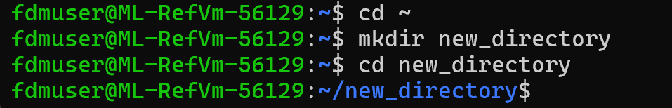
 | touch file1 file2 file3 | Create empty files in the current directory
 | ls | Verify file creation  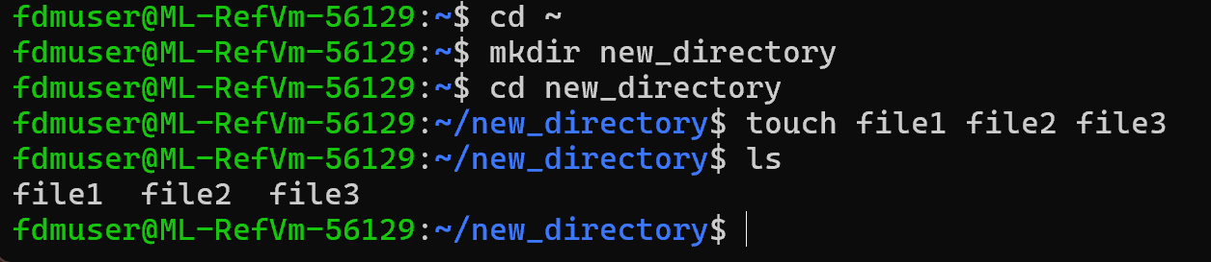
 | mkdir sub_directory | Create a subdirectory under the current directory
 | mv file1 sub_directory/ | Move a file into the subdirectory
 | ls  ls sub_directory/ | Check the directory structure  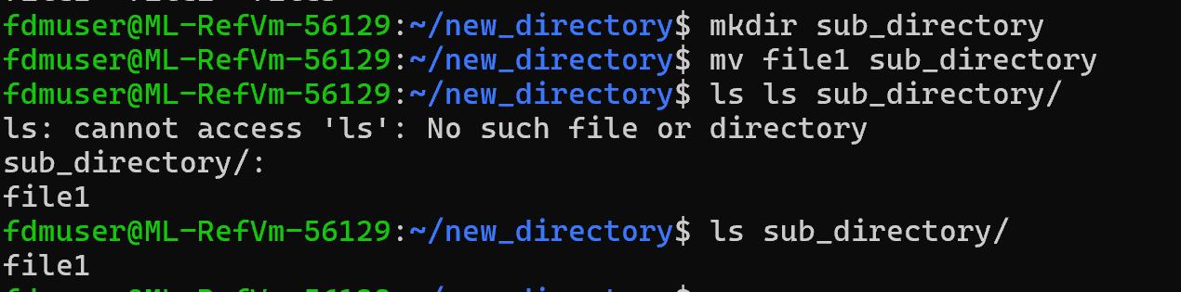
 | rm file2 | Delete a single file
 | rmdir sub_directory/ | - This should fail  - Check the reason why  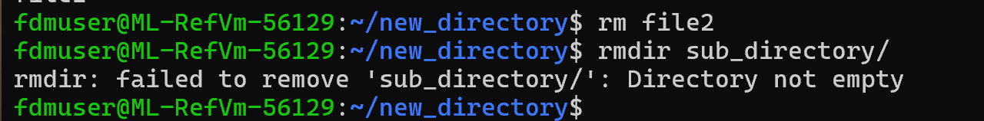  Rmdir can only remove empty directories.  So if sub_directory has any file or folder inside it, even hidden files, rmdir will fail
 | rm -r sub_directory/ | This works
 | cd ..  rm -r new_directory/ | Finish cleaning up  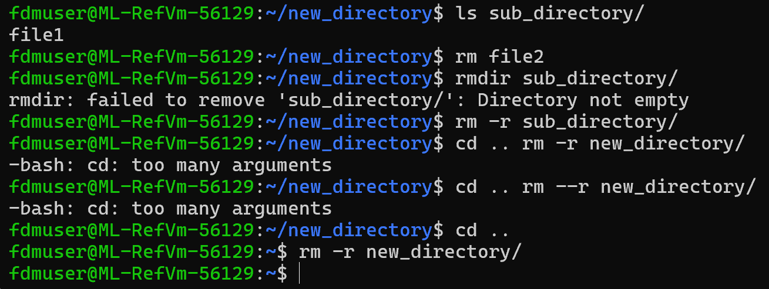

Introducing wildcards – asterix and ?

- Consultants should work in their own home because of file system permissions.

Activity

Try the following commands in a Bash session:

 | touch new_file  mkdir new_directory | Create a new file and directory with similar names
 | ls new_file new_directory | In a single command list the new file and directory
 | ls new* | - List both with a wildcard  - The result looks like the previous step  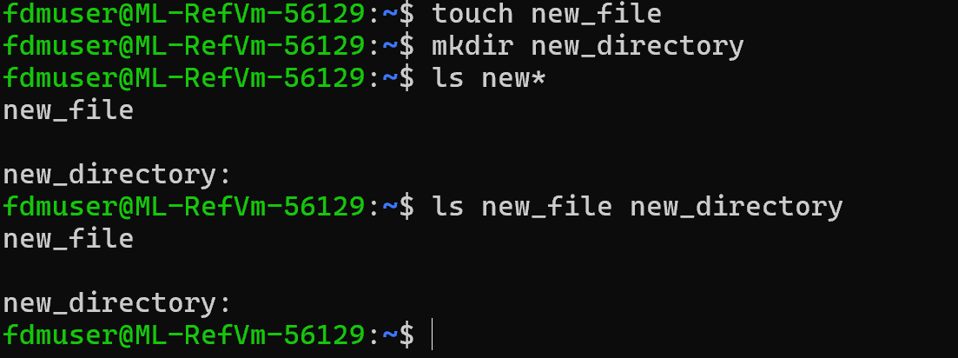
 | touch new_data | Create another file
 | rm -r new*  ls new* | - Deletes all items that start with new  - new* included new_data as well  - This is a warning about possible human error  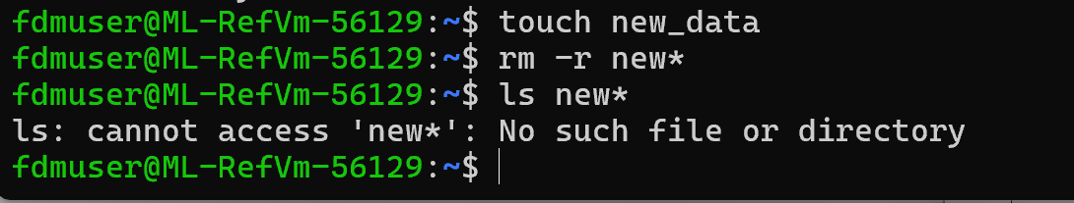
 | touch file1 file99 data1 | Create these 3 files
 | ls file*  ls file?  ls *1  Confused about this | Test what these commands return  Answer the following questions  If needed rerun the touch command between attempts to replace the files  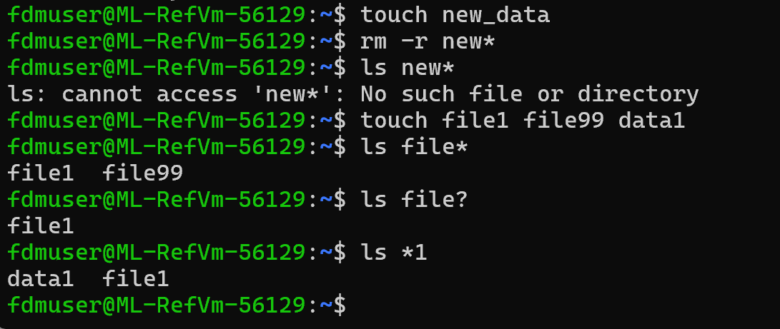
Which command lists every file that has ‘file’ as the start of the name

ls file*

Which command lists any filename that begins with any four characters and the number 1 as a filename?

Hint: listing four characters only cannot be done using an *
ls ????1

Redirection to create a file / persist data

- The touch command was used to create empty files in previous steps.
- Like with desktop computing many people use editors to create files with contents.
- Editors to learn in this environment include:
vi - modern version is vim but still called vi
nano - more features but not always there
- Another method is to capture output for a command and save as a file.
- This operation should be thought of as redirecting the default output from the command away from the screen to the file.
- There are a few ways for redirection to work.
- Online reference: https://www.gnu.org/software/bash/manual/bash.html#Redirections

Activity

Try the following commands in a Bash session:

 | cd ~ | Make sure you are in home so that you have access to create files
echo ‘Hello, World!’ > file.txt
ls file.txt
cat file.txt
echo ‘More text’ > file.txt
cat file.txt

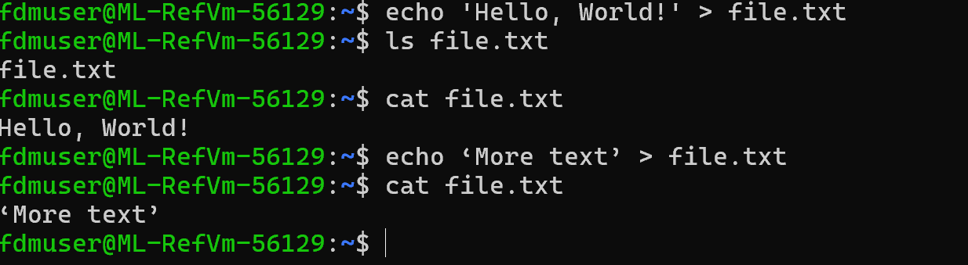
• echo 'Hello, World!' prints the literal text Hello, World!.
• > (redirection) sends that text into file.txt.
- If file.txt doesn’t exist, it’s created.
- If it does exist, it’s overwritten.
• ls lists files.
• Output file.txt confirms the file is present in the current directory.
Cat prints the contents of the file to your terminal. You see, hello, world!

For echo ‘more text’> file.txt
• Again, > overwrites the file.
• Now file.txt contains only:

Cat file.txt
Confirms the current contents “More text”

Where did the original contents ‘ Hello, World! ’ of file.txt go?

The command eacho'More text' > file.txt first performs the output redirection, which truncates file.txt to zero length. Then Bash tries to run the command eachoMore text, which does not exist. Because the redirection happens before the command is executed, the file is emptied even though the command fails.
Therefore, the original “Hello, World!” content was overwritten and lost when the file was truncated.

Can the original contents be retrieved if it is important data?

It is not possible to recover the original file as it was overwritten.

echo ‘Another line’ >> file.txt

View the contents of the file now
Confirm there are 2 lines of text –

‘More text
Another line’
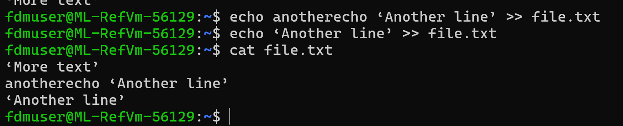

The >> arrows just adds on new line instad of replacing the contents in the file

Activity

- Find out syntax and options for each command.
- Use at least 2 options for each command.
- Write down what you did.

 | echo | Echo [options] [string]  echo LONG-OPTION  echo means – display a line of text  Echo the STRING(s) to standard output.  -n do not output the trailing newline  -e enable interpretation of backslash escapes  If -e is in effect, the following sequences are recognized:  \\ backslash  \a alert (BEL)  \b backspace  \c produce no further output  \e escape  \f form feed  \n new line  \r carriage return  \t horizontal tab  \v vertical tab
 | cat | Cat [option] [file]  -A, --show-all  equivalent to -vET  -b, --number-nonblank  number nonempty output lines, overrides -n
 | cp | Cp- copy files and directories  cp [OPTION]... [-T] SOURCE DEST  cp [OPTION]... SOURCE... DIRECTORY  cp [OPTION]... -t DIRECTORY SOURCE...  -a, --archive  same as -dR --preserve=all  --attributes-only  don't copy the file data, just the attributes  --backup[=CONTROL]  make a backup of each existing destination file
 | mv | mv- move (rename) files  mv [OPTION]... [-T] SOURCE DEST  mv [OPTION]... SOURCE... DIRECTORY  mv [OPTION]... -t DIRECTORY SOURCE...

Activity

Answer the following questions:

What is a valid use case for ‘echo -n’ for different from just ‘echo’ ?

-n does not output the trailing new line.

What problems are there reading a longer text file using ‘cat’ ?

Cat prints the entire file at once, so long files fly past the screen and you can’t read them.

Most terminals only keep a small scrollback buffer, so you may not be able to scroll up far enough to see everything.

Cat doesn’t let you search for words or jump to specific parts of the file
If the file contains hundreds or thousands of lines, it becomes overwhelming and difficult to find what you need.

Use less file.txt, more file.txt
• scroll up/down
• search (/word)
• exit with q
Instead

View information stored in a file with different commands -
- cat /student_files/day1/poem1
“Two roads diverged in a yellow wood,
And sorry I could not travel both
And be one traveler, long I stood
And looked down one as far as I could
To where it bent in the undergrowth;

Then took the other, as just as fair
And having perhaps the better claim,
Because it was grassy and wanted wear;
Though as for that the passing there
Had worn them really about the same,

And both that morning equally lay
In leaves no step had trodden black.
Oh, I kept the first for another day!
Yet knowing how way leads on to way,
I doubted if I should ever come back.

I shall be telling this with a sigh
Somewhere ages and ages hence:
Two roads diverged in a wood, and I -
I took the one less traveled by,
And that has made all the difference.

-By Robert Frost, 1916”
- more /student_files/day1/poem1
Two roads diverged in a yellow wood,
And sorry I could not travel both
And be one traveler, long I stood
And looked down one as far as I could
To where it bent in the undergrowth;

Then took the other, as just as fair
And having perhaps the better claim,
Because it was grassy and wanted wear;
Though as for that the passing there
Had worn them really about the same,

And both that morning equally lay
In leaves no step had trodden black.
Oh, I kept the first for another day!
Yet knowing how way leads on to way,
I doubted if I should ever come back.

I shall be telling this with a sigh
Somewhere ages and ages hence:
Two roads diverged in a wood, and I -
I took the one less traveled by,
And that has made all the difference.

-By Robert Frost, 1916
- less /student_files/day1/poem1
Two roads diverged in a yellow wood,
And sorry I could not travel both
And be one traveler, long I stood
And looked down one as far as I could
To where it bent in the undergrowth;

Then took the other, as just as fair
And having perhaps the better claim,
Because it was grassy and wanted wear;
Though as for that the passing there
Had worn them really about the same,

And both that morning equally lay
In leaves no step had trodden black.
Oh, I kept the first for another day!
Yet knowing how way leads on to way,
I doubted if I should ever come back.

I shall be telling this with a sigh
Somewhere ages and ages hence:
Two roads diverged in a wood, and I -
I took the one less traveled by,
And that has made all the difference.

-By Robert Frost, 1916

Less command outputted entire file , and had to press q to exit to the terminal

Which command from the previous question provides the easiest navigation to read a large file?

- less /student_files/day1/poem1

What does ‘cp -R’ copy ?

It copies a folder and all of its contents including sub folders and all files inside

What are the 2 basic uses of mv command?

To rename files or directories:

mv oldname.txt newname.txt
changes the file name

mv file.txt folder/
Move files into a different directory

Using data

Using data in the file system and streams

Online reference: https://www.gnu.org/software/bash/manual/bash.html#Shell-Builtin-Commands

Locate files in the filesystem or search data within files

- Data usually has metadata.
- The file system contains both.
- Different command reference or modify one or the other.
- Sometimes we need to use both.

Activity

Try the following commands in a Bash session:

Find a file by name in the filesystem -

find /student_files -name brokers.dat

prints out : /student_files/brokers.dat

What command would you use to find all ‘dat files’ in /student_files ?

NB: Very common terminology for file with a ‘.dat’ suffix

find /student_files -name "*.dat"

Output:
/student_files/companies.dat
/student_files/currency.dat
/student_files/broker_exchange.dat
/student_files/stockExchanges.dat
/student_files/transactionType.dat
/student_files/shareHolders.dat
/student_files/brokers.dat
/student_files/shares.dat
/student_files/trades.dat
/student_files/places.dat

What are some other metadata attributes can you use to search with using the ‘find’ command ?

List at least 3 –
find /path -size +1M – finding files larger than 1 MB

find /path -type f # files
find /path -type d # directories
searching for files, directories, links etc

find /path -mtime -7
finds files modified in the last 7 days

The find command defaults to searching an entire subdirectory for answers.
What argument can be used to only search one level ?
find /student_files -maxdepth 1 -name "*.dat"

Compare the ‘find’ command with ‘ls -R’ to see what you can find in subdirectories

Ls -R lists everything in all subdirectories, cannot search or filter shows too much
Find – searches through all subdirectories, can filter by name, type, size, date

Search for information inside a file using the ‘grep’ command –

grep Smith /student_files/brokers.dat

grep – used to search for text inside files.
Smith – this is the pattern(text) you’re searching for.
It looks through the file brokers.dat and shows every line where the name “Smith” appears

1:John:Smith
13:Bruce:Smith

# Search recursively through the filesystem for information in the files –

grep -r Smith /student_files/

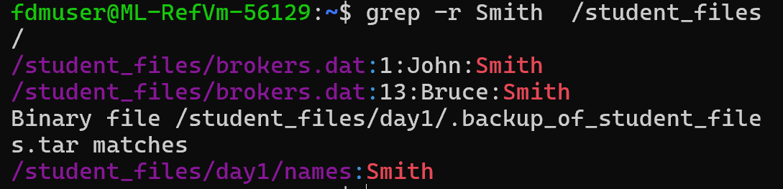
Your grep command found every place where “Smith” appears inside /student_files and listed the files and lines where it was found.

Try this to combine searching multiple files for the same content –

cat /student_files/* | grep Id (capital I with lower case d)
cat /student_files/*
- cat displays the contents of all files in the /student_files directory.
- The * wildcard means “every file in this folder”.
- It does NOT include subdirectories — only files in the top level.
2. | (pipe)
- Sends the output of cat into another command.
- Think of it as: “take this output and pass it to the next command”.
3. grep Id
- Searches for the exact text “Id” inside the combined output.
- Matching is case-sensitive:
  - It will match “Id”
  - It will NOT match “ID” or “id” or “iD”
4. The result
You get all lines from all top-level files that contain “Id”.

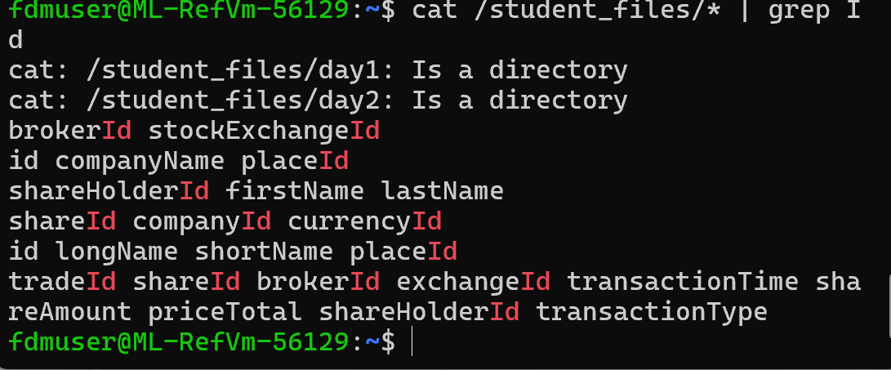
In the previous questions grep -r doesn’t need cat because it already searches files and subdirectories by itself.

Another way to do this command is grep Id /student_files/*

Q: Why are files useful if we want to use information after rebooting ?

Because files store information permanently.
When you reboot a computer, everything stored in RAM (memory) is erased.
But files are stored on permanent storage, such as:
- hard drives (HDD)
- solid-state drives (SSD)
- USB drives
- cloud storage
This means the data stays there even after shutting down or restarting the system.

Pipes

- Files persist information between tasks and shutdowns or crashes.
- To use the information immediately we use pipes to take information to the next process.
- Many commands do not need pipes if they have ‘action’ arguments
e.g. find.

Activity

Try these commands to redirect output that would normally go to the screen to another command instead.
A few commands introduced here will be explored in more detail later:

Use a pipe to extract the second column from data (delimited by spaces) –

Expected output: banana

- echo ‘apple banana cherry’ | cut -d' ‘ –f2
• echo 'apple banana cherry' prints the text.
• The pipe | sends that text to the next command.
• cut -d' ' -f2 splits the line on the space delimiter (-d' ') and returns the 2nd field (-f2).
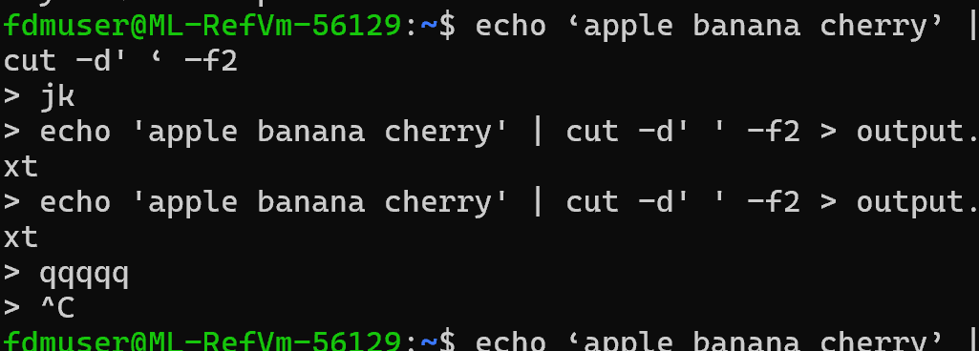

Help
Ctrl c to exit out of it

Use a pipe to map all lowercase letters with uppercase –

- echo ‘hello world’ | tr 'a-z' 'A-Z’
- echo ‘hello world’ | tr [:lower:] [:upper:]
- echo ‘hello world’ | awk '{print toupper($0)}’
- echo ‘hello world’ | sed 's/[a-z]/\U&/g’

NB:
tr translates or removes strings
awk applies methods to matched patterns
sed is a stream editor

All of these convert it to HELLO WORLD

Count lines, words, and characters in a file
Expected output: 1 2 12

- echo ‘Hello world’ | wc

How many words are found in this string –
Expected output: 2

- echo ‘Hello world’ | wc -w

Which ‘wc’ option returns how many characters ?
Replace ??? with a valid option in ‘wc’

- echo ‘Hello world’ | wc -???
echo -n 'Hello world' | wc -m

11

Write to a file while also displaying the output -
Expected outputs:
  - Hello, world! to the screen
  - output.txt in the current directory with same contents

- echo ‘Hello, world!’ | tee output.txt

confirm output to screen
cat output.txt to confirm output to file as well

echo 'Hello, world!' | tee output.txt
tee output.txt means:
👉 “Write this to the screen, and also save it into output.txt.”
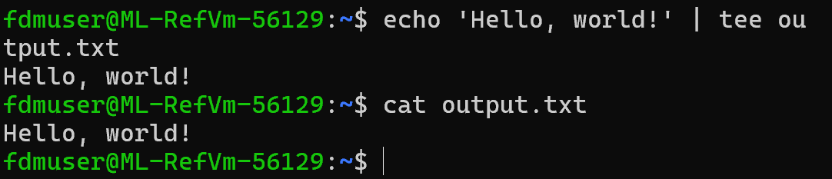

grep command

- Get help on grep command before answering questions.
- Answers will be discussed in class.

Activity

How can you search for strings with case sensitivity ?
Use the grep command without the -i (ignore case) option.

- Example: grep ‘StringToSearch’ filename

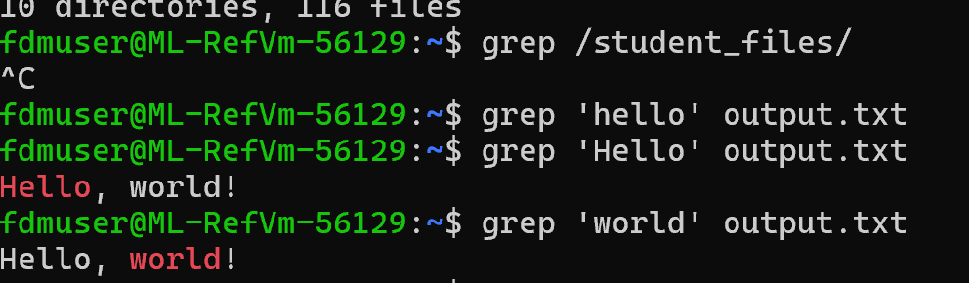

Count how many times a string or word is found in a file ?
Use grep with the -c option to count the number of matching lines.

Example: grep -c ‘StringToCount’ filename

If counting individual words is required, combine grep with wc -

- Example: grep -o ‘word’ filename | wc -l

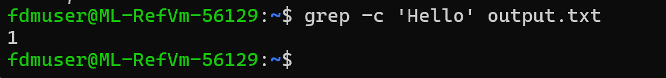

What is the difference between string and word, and which option is used in grep ?
Use grep -w to search for whole words.

Example: grep -w ‘word’ filename

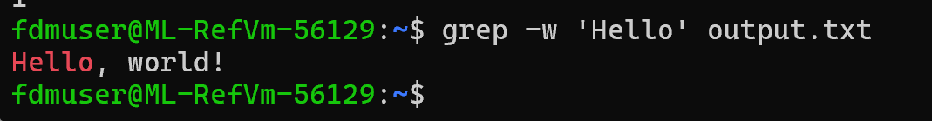

Give an example of why to use -v.
The -v option in grep inverts the match, showing lines that do not contain the specified string.

Example use case - To filter out comments (lines starting with #) from a configuration file:

- grep -v ‘^#’ configfile
- 

Using Commands

Commands for basics

- A short list of commands that are useful to develop skills with.
- This is a chance to learn how to research documentation to find commands as needed.
- Online reference: https://www.gnu.org/software/bash/manual/bash.html#Shell-Builtin-Commands

Activity

Try the following commands in a Bash session.
Learn more about builtin commands:

 | Command | Notes
 | type cd | - Check what type of command `cd` is  - Expected output:  ‘cd is a shell builtin’  - Write your answer below  “cd is a shell builltin”  - What does the ‘type’ command do?  It checks what type of command it is
 | which cd | - Expected output:  ‘/usr/bin/cd’  - Write your answer below  It did not output anything
 | ls /usr/bin/ | - List the location of the `cd` executable  - Expected output:  [directory listing of files in that folder]  - What does this folder contain ?  Hint: pipe ls output to less command to scroll through listing  ls /usr/bin | less  It lists all of the files in the bin directory.
 | cat /usr/bin/cd | - Display the `cd` executable  - Expected output:  #!/bin/sh  builtin cd "$@"  - This is a shell script that points to the builtin command ‘cd’  NB: This is hard to explain because it is built-in. There is more depth to Bash than covered here  Hint: help builtin

Activity

The most obvious difference between a CLI and a GUI is that an operator must remember enough commands to get the job done instead of selecting available options on a screen.

Familiarise yourself with this subset of Bash commands and describe what they do. Don’t forget to explore some of the available options. You will get to use many commands and their options after this activity.

They are grouped by general use:

System management –

 | Command | Notes
 | Sudo | IT stands for superuser do
 | chmod | Lets you set who can read/write/execute a file or folder.  Means change file permissions
 | chown | Change file owner and group  Changes which user and group owns a file.
 | du | Disk usage  Shows how much space files and directories use.
 | users | Shows currently logged-in users  Prints the usernames of people logged into the system.
 | who | Show session details of logged-in users  Shows who is logged in, and from where.
 | passwd | passwd — Change a password  Lets a user change their own password, or an admin change another user's password.
 | alias | Create a shortcut command  alias ll="ls -la"  alias update="sudo apt update && sudo apt upgrade"

Files and File system –

 | Command | Notes
 | pwd | Print working directory  Tells the current directory
 | basename | basename takes a full file path and returns only the filename, removing any leading directory path.  $ basename /home/user/data/report.csv  report.csv
 | dirname | dirname takes a full file path and returns only the directory portion, removing the filename.  $ dirname /home/user/data/report.csv  /home/user/data
 | head | head displays the first lines of a file.  By default, it shows the first 10 lines, but you can choose a different number with -n.  $ head data.csv
 | tail | tail displays the last lines of a file.  By default, the last 10 lines, but you can change that.  $ tail data.csv

Text processing –

 | Command | Notes
 | awk | Used to scan and process text line by line  It works with fields (columns) and allows filtering, printing, and manipulating data.  Print the second column  awk '{print $2}' output.txt  print only lines where column 3 > 100  awk '$3 > 100' output.txt
 | sed | Find, replace, delete or edit text without opening the file  Replace “apple” with “orange”  sed 's/apple/orange/' fruits.txt  delete line 3  sed ‘3d’ file.txt
 | date | date displays the current date and time.  It can also format the output using special format codes.  Basic use: date  Custom format example :  date "+%Y-%m-%d"
 | cut | Extracts columns or specific character ranges from text  Get column 1 and 3 (comman seperated)  cut -d ',' -f 1,3 data.csv  Explae first 5 characters  Cut -c 1-5 file.txt
 | tr | tr is used for character-level transformations, such as:  - changing case  - removing characters  - replacing characters  convert lowercase to uppercase:  echo "hello world" | tr 'a-z' 'A-Z'  Removing digits  echo "abc123def" | tr -d '0-9'  Replace spaces with underscores  echo "a b c d" | tr ' ' '_'
 | sort | sort arranges lines of text in ascending or descending order.  sort output.txt
 | uniq | uniq removes adjacent duplicate lines.  Often used with sort because duplicates must be next to each other.  For example  apple apple banana banana banana orange for items.txt  uniq items.txt  apple banana orange

Text output handling

- The output from the echo command is just text with new line characters embedded.
- The new line characters are read as well but just displayed as a new line on the screen usually.
- echo does not persist information as a file.
- It is being using in these exercises instead of text files which also have new line characters to demonstrate other commands.
- This is how we often use examples in Python code where there is data loaded into a variable.

Activity

Try these commands in a Bash session to see how they work:

What does ‘\n’ do in this context –
Expected output:
banana
apple
cherry

- echo –e ‘banana\napple\ncherry’

Hint: look up ‘echo’ in the Bash builtin commands reference to understand what ‘echo -e’ does and find out what options are available

\n inserts a line break
-e enables interpretation of escape sequences like \n, \t, etc.

How to sort lines in text –
Expected output:
apple
banana
cherry

- echo -e ‘banana\napple\ncherry’ | sort

sorts in alphabetical order

Remove duplicate lines from sorted data -
Expected output:
apple
banana

echo -e ‘apple\napple\nbanana’ | uniq

NB: You cannot remove duplicate lines from unsorted data

Remove duplicate lines from this data -
Expected output:
apple
banana
apple

- echo -e ‘apple\nbanana\napple ’

Write down your answe

Apple
banana

Activity

- Find out what each command does before answering questions.
- They should be considered in the same way as a method imported from a library in a language like Python.
- What options might be useful to do imagined tasks ?

Which commands are more useful for interactive commands to do something in a Bash session that commands used in a script?

- Provide two examples:
Cd
Ls

‘chown’ will sometimes require the operator to use ‘sudo’ first.

- Why?

Some system actions are restricted for security (e.g., installing software, modifying system files, changing ownership).
sudo temporarily elevates your permissions so the command can run.
Sudo verifies you are allowed to run admin commands by asking for the password

sudo lets a normal user temporarily act as the root user to run commands that require higher privileges. sudo chown user file.txt

sudo chown user file.txt

Use the ‘date’ command with formatting options to do the following:

- Return the day of the week

date "+%A"

- Return the current date in YYYYMMDD format
date "+%Y%m%d"

- What does this command do: date -d ‘2000/01/01’ ‘+A%’

-d '2000/01/01'
Tells date to use the date "January 1, 2000" instead of the current date and prints the anme of the day of the week.

‘head’ and ‘tail’ are used to sample large text files.

- How can I get everything but the header line on a .CSV file?
tail -n +2 input.csv
+2 means “start output from line 2”.
Save to a new file:
tail -n +2 input.csv > noheader.csv
``

- Can you find a way to do it with ‘grep’ too?
Skip the header by matching its text.
grep -v '^name,age,city$' file.csv

Skip the first line using line numbers(grep -n)
grep -n '' file.csv | grep -v '^1:' | cut -d: -f2-

Pipe the results from a suitable command to ‘grep’ to find just your login session using your login name as the grep string.

- Write down how it was done

who | grep -w "$(whoami)"

Workflow automation

Commands are designed to use together
- We can perform an action based on arguments or conditions.
- We can also chain together command with pipes.
- There are a few different ways it can work.

Using results with ‘action’ arguments

Some commands include an action argument like grep, tar, sed, rsync.

Activity

- Get help on ‘find’ before answering questions.
- There are three parts to the ‘find’ command implemented using different options.
- Answer the following questions:

The first part of ‘find’ refers to the starting point in the file system where the search starts.

- What command option is used ?

find ... [path...] [expression]
find -name "*.txt"

- What is the default value if it is not specified ?

default path is the current directory

The second part of ‘find’ refers to metadata attributes that we can use.

- How can we specify to find files with a specific name ?
find <path> -name "filename"

Example:

find . -name "notes.txt"

This allows for search where file names match given pattern

- Can we use wildcards?

find <path> -name "pattern*"

Example:

find . -name "*.txt"

- Identify three other attributes instead of name that can be used?

Search by file type
find <path> -type f # files
find <path> -type d # directories

search by file size
find <path> -size +10M # larger than 10 MB
find <path> -size -1k # smaller than 1 KB

The third part of ‘find’ provides ‘action’ options.
The default action is to display the search results to the screen.
This is the ‘-print’ option.

- What action option can I use instead if I want to delete all the files returned in the results?
find . -type f -name "*.tmp" -delete
find . -type f -name "*.tmp" -print- run this first, before deleting check what is going to be deleted.

- What action option can I use to execute another Bash command against each file in the results?
find <path> -type f -name "<pattern>" -exec <command> {} \; Per file (one command per result):

find <path> -type f -name "<pattern>" -exec <command> {} + Batched (fewer invocations; passes many files to the command at once):

- What is the exact command used to search for all dat files in /student_files and all sub-directories and return the result of the ‘wc’ command on each?

find /student_files -type f -name "*.dat" -exec wc {} \;

Using Conditionals for actions

Actions can also be performed only when conditions are right.
When writing code that will be re-used and maintained it is often better to use easier to read syntax like with ‘if…then…else’.
There are also alternate syntaxes which do the same thing.

Activity

Answer the following questions using a Bash session:

This is an ‘if’ statement testing if file.txt exists in the current directory

# if statements using a file condition
if [ -f ‘file.txt’ ]; then
echo ‘File exists.’
else
echo ‘File does not exist.’
fi

- Test it out by entering each line followed by the <enter> key

NB: Bash is case sensitive but does not need indents etc as consecutive spaces are ignored

It returned “File exists”

Modify the statement to check if /student_files/brokers.dat exists

- What modified code did you use?
if [ -f "/student_files/brokers.dat" ]; then
echo "File exists."
else
echo "File does not exist."
fi

This is an alternate more compact syntax for ‘if’ statements
Read it as ‘Only do && action if a file exists otherwise do the || action’

[ -f file.txt ] && echo ‘File exists’ || echo ‘File does not exist’

- Test it out by entering it followed by the <enter> key
It returned ‘File exists’

- Try to use it for making an ‘if … then’ statement without else?
if [ -f "file.txt" ]; then
echo "file.txt exists."
fi

- Try to use it for an ‘if … else’ statement without then?

[ -f "file.txt" ] && echo "file.txt exists." || echo "file.txt does not exist."

Three Types of Conditions in Bash

- File conditions: test attributes of files, such as existence, type, or permissions.
- String conditions: test properties of strings, such as equality or emptiness.
- Numeric conditions: compare numeric values using operators like -eq, -ne, -gt, -lt, etc.
- Online reference: https://www.gnu.org/software/bash/manual/bash.html#Bash-Conditional-Expressions

Activity

- Previous examples have used a file condition.
- Use literals and/or variables to answer the questions using a Bash session:

- Write a statement and test it that compares if ‘1’ = ‘1’ as a string
if [ "1" = "1" ]; then
echo "They are equal."
else
echo "They are not equal."
fi

- Also test if ‘1’ = ‘2’ gives a different result
if [ "1" = "2" ]; then
echo "They are equal."
else
echo "They are not equal."
fi

- Write down the statements used

- Write a statement and test it that compares if ‘10’ > ‘1’ numerically
if [ 10 -gt 1 ]; then
echo "10 is greater than 1."
else
echo "10 is NOT greater than 1."
fi

- Also test if ‘1’ > ‘1’ gives a different result
if [ 1 -gt 1 ]; then
echo "1 is greater than 1."
else
echo "1 is NOT greater than 1."
fi

- Write down the statements used

Combining Conditions

- You can combine these conditions using logical operators:
AND: [ condition1 ] && [ condition2 ]
OR: [ condition1 ] || [ condition2 ]
NOT: ! [ condition ]
- NB there are a few alternate syntaxes for doing the same thing – pick one
- Online reference: https://www.gnu.org/software/bash/manual/html_node/Bash-Conditional-Expressions.html

Activity

Previous examples have used a single condition.
Use literals and/or variables to answer the questions using a Bash session:

- Combine more than one type of test into a single query
- Provide a statement that checks if a string is longer than 3 characters and that ‘9’ < ‘11’ numerically and echos ‘OK’ if both are true

str="abcd" # example input string

if [[ ${#str} -gt 3 && 9 -lt 11 ]]; then
echo "OK"
fi

str="hi"

if [[ ${#str} -gt 3 && 9 -lt 11 ]]; then
echo "OK"
else
echo "Condition NOT met"
fi

Exit Status for Conditional Execution and Flow Control

- The success or failure of the last command run can used to determine what happens next.
- This is called the exit status.
- Conditionals work using exit status as core mechanism.
- Not just Boolean.
- Online reference: https://www.gnu.org/software/bash/manual/bash.html#Exit-Status

Activity

- Try the following commands in a Bash session:

 | Command | Notes
 | ls | - Any command that can complete without an error can be used here instead of ‘ls’  - Other examples include cd, echo, type  if echo "Hello"; then  echo "echo succeeded"  fi  if cd /fake; then  echo "OK"  else  echo "Fail"  fi  if type ls; then  echo "ls is a command"  fi  if ls; then  echo "OK"  else  echo "Not OK"  fi
 | echo $? | - This returns the completion status of the last command  - The expected value for a command that worked is ‘0’ (zero)  ls  echo $?  Would be 0  ls /no/such/path  echo $?  It would be 2 (or another non-zero value – it just means that it didn’t work)
 | ls no_file | - Any command that completes with an error message can be used here  - If the ‘ls’ command cannot find ‘no_file’ in the current directory it returns an error message  - The expected value returned is  ls: cannot access no_file: No such file or directory’
 | echo $? | - The expected value for a command that did not work is not ‘0’ (zero)  - The expected value returned in this case is  2
[ -f file.txt ] && echo ‘File exists’ || echo ‘File does not exist’

- Which condition is run if the conditional test returns a non-zero value
“File does not exist”

- The return status is not just Boolean returning zero and one
- What is the benefit of having as many error codes as common error types for a command or script?

Having multiple exit codes allows a command or script to indicate specifically what kind of error occurred, instead of just whether it succeeded or failed. This makes debugging easier and enables scripts to make smarter decisions based on the exact reason a command failed.

Flow control mechanisms

- Bash scripts use flow control to run the right commands under the right conditions and dealing with results that are returned each time the code is run.
- As the conditions in the computing environment will be different each time the code is run these are known as ‘run-time’ situations and potentially errors.
- Examples of each of these mechanisms will be illustrated in the code examples that follow.

Conditionals

Online reference: https://www.gnu.org/software/bash/manual/bash.html#Conditional-Constructs

- if...then...elif…else: Conditional execution based on a test
- case: Multi-way branching for evaluating variables against patterns
- select: Menu-driven loop for user input selection

Loops

Online reference: https://www.gnu.org/software/bash/manual/bash.html#Looping-Constructs

- for: Looping through a list of items
- while: Looping based on a condition being true
- until: Looping until a condition becomes true

Modifying flow to handle errors etc

- break and continue: Used to exit loops (break) or skip to the next iteration
- exit: Used to terminate a script or shell session and optionally return a status code to the operating system or the calling process

Automating Bash commands

- Commonly used for automating tasks, managing system operations, and executing sequences of commands in Unix-like systems.
- Use-cases emphasise text processing, file manipulation, and process management.

Bash script facts

- A Bash script is a series of Bash commands that do some tasks together.
- The script is created so the task can be repeated easily.
- This is more efficient and helps prevent human error.
- It might be a few lines or 100’s.
- Comments should be used to document instructions to make updates easier.
- It is saved as a text file.
- Files have a path which includes name and location.
- Give it a name like ‘myscript’.
- Save it to a directory so that it can be found again like home (~) .
- It should have ‘x’ permission set using ‘chmod’.

chmod u=rwx,g=rx,o=x ~/myscript
or
chmod 751 ~/myscript

- Each time a script is run the environment is different so conditional tests can be run to deal with the situations and results.
- Run time options and or arguments can be used to customise how the execution works differently each time it is run.
- It can be run from Bash with an argument ‘Hello’ like:

~\myscript Hello

- A sample script that can use the ‘Hello’ run time argument and some commands and other features already covered previously like variables.

#!/bin/bash
# A very simple Bash script
# first line started with a shebang and is not a comment
# Greet using an env variable if argument was provided

[ -n $1 ] && echo $1 $USER

# List their home directory

echo –e ‘\nYour home directory is $HOME’
echo ‘It contains these subdirectories and files:’
ls -l -S $HOME

Scripting with examples

- It is faster to learn how to create a Bash script by learning from examples.
- The following example is not a useful script except to learn how to use different features in Bash scripting.
- The first example will include the following features –

- Variables
- Command substitution
- Positional parameters
- Control structure - conditionals
- Control structures - loops
- Control structure - functions
- Exit codes from commands or processes

Bash script – Example 1

- Try lines of code as individual commands to see how they work.
- Understand how each feature is delivered.
- Use online references to find out what else these features do.

#!/bin/bash
# A simple Bash script demonstrating various features
# first line started with a shebang
# 1. Variables
name=’World’

# 2. Command substitution
current_date=$(date +’%Y-%m-%d’)

# 3. Positional parameters passed in when starting a script
greeting=$1

# 4. Conditionals like if...then...elif...else, case, break, continue
if [[ ! -f output.txt ]]; then
echo ‘Old output not found - output.txt’
else
echo ‘Something went wrong!’ >&2
fi

# 5. Control structures for loops like for...do, until...do
for i in {1..3}; do
echo ‘This is line $i’ >> output.txt
done

# 6. Functions
print_summary() {
echo ‘Number of lines of text found in output file:’
wc -l < output.txt
}
print_summary

# 7. Exit codes from commands or processes can be used
exit 0

Activity

- Try the following commands in a Bash session:

 | Command | Notes
 | env | Variables and environment variables (env)  - Variables store information  - Environment variables store information about the shell environment, such as user info, system paths, and configurations  - Also works like normal variables  - Shared by child processes
 | x=’a string’  echo $x  export x  env | grep x | ‘export’ command  - converts a variable to an environment variable
 | echo $HOME  echo $USER  env|grep USER | Displaying Environment Variables
Command Substitution
Purpose: Capture the output of a command and use it as a variable or inline in other commands.

Type this in line by line and make it run-

for file in $(ls /student_files/*.dat)
do
echo
ls $file
cat $file
done

 | ls not_found | Answer the following question-  Special Parameters:  $0: The name of the script or function being executed  $1, $2, $3, ...: The first, second, third, etc., arguments provided to the script or function  $#: The total number of arguments passed  $@: All arguments as a single word (can be used in loops)  $*: All arguments as a single string (slightly different from $@ in quoted contexts)  When a command like ‘ls’ returns an error message it starts with identification of the source of the error and includes details about the error  - What $ parameter can be used to return the name of the command or script that had the error?  - What $ parameter can be used to return all the arguments to display in the error message?
Conditionals

Where can conditionals be used in Bash ?

Exit codes

If exit is used to end a Bash script then what can respond to any exit codes?

Example 2 – operator inputs

- Learn how the script ensures the correct operator response before exiting the loop and continuing execution.
- This approach ensures that -
  - Invalid inputs are caught and handled.
  - The user is guided clearly until they provide the correct response.
  - The script moves forward only when valid data is received.

- Continuous prompting:  The while true loop ensures that the user is repeatedly prompted to enter a PIN until the correct input is provided.  - Input validation:  The length of the user-provided PIN is validated using [ ${#pin} -lt 5 ].  ‘If’ is used to notify the user of any errors –  ‘Pin too short - Please try again.’  - Clear error feedback:  Error message explicitly states what is wrong, guiding the user to retry with a valid input (a PIN with at least 5 digits).  - Condition for valid input:  Once a PIN of 5 or more digits is entered, the else block executes, which breaks the loop and allows the script to proceed.  - Break vs. continue logic:  The script uses break (not continue) to exit the loop.  Using continue would have restarted the loop even with valid input, causing unintended behaviour. | #!/bin/bash  # Script to validate a pin number with  # at least 5 digits  # Check if the length is less than 5  # If pin is too short, notify the user and  # repeat the loop  while true; do  echo ‘Pin num should have 5+ digits.’  read -p ‘Enter pin number: ‘ pin  if [ ${#pin} -lt 5 ]; then  echo ‘Pin too short - Try again’  else  # If pin is valid, exit the loop  # use break not continue  break  fi  done  echo ‘Pin number is accepted’

Example 3 – reading files

- Learn how to ensure correct file reading and processing.
- There are other methods to read and use the contents of files.

- File existence check:  The if [[ -f ‘$file’ ]] condition ensures that each provided file exists and is a regular file before attempting to read it.  - Iterative file processing:  Using a for loop, the script iterates through all file arguments (‘$@’).  Each file is individually checked and processed, allowing the user to pass multiple files at once.  - Reading files line by line:  The ‘while read -r’ line loop reads the file line by line after the file is fed into the loop using “done < ‘$file’ “  This ensures that even large files can be processed without exhausting system memory, as only one line is read into memory at a time.  - Immediate feedback:  For each line read, some operation can be performed.  - Error handling:  If a file does not exist, the script gracefully handles the error and continues processing the next file, ensuring robustness and preventing the entire script from failing. | #!/bin/bash  # Script reads line by line all files  # given as arguments  for file in ‘$@’; do  # Checks if each file exists before use  if [[ -f ‘$file’ ]]; then  echo ‘Processing file: $file’  while read -r line; do  echo ‘$line’  sleep 0.5  done < ‘$file’  else  echo “Error: File '$file' doesnt exist.“  fi  done

3 versions of similar code to explore and develop

Using the following three versions of this Bash script to learn –

1. Understanding incremental development
- In Version 1, the script simply prints a message based on the option. Version 2 adds computational functionality, and Version 3 introduces modularity with functions.

2. Learning modular design with functions
- Version 3 introduces the use of functions (optFunc and mathFunc), which segregate logic for option parsing and computation.
- Functions make the code more reusable and easier to debug.
- Best practice for maintainable and scalable scripting.

3. Mastering Boolean flags for flexibility
- Versions 2 and 3 develop the uses of Boolean flags (add, subtract, etc.) to allow multiple operations to be performed on the same input.
- Version 3 flexibility means you can run addition and multiplication in a single execution, unlike Version 2, which supports only one operation per run.

4. Error handling and user feedback
- Error-handling mechanism improves across versions, teaching robust scripting practices.
- Version 1's error messages are generic, whereas Version 2 and 3 provide detailed feedback (Bad Option - $OPTARG), guiding users to correct their input.

5. Practicing input and argument handling
- Version 3’s use of shift and $@ allows it to process multiple inputs dynamically.

Version 1

- Option parsing with getopts:  The while getopts :asmd opt block processes command-line options (-a, -s, -m, -d).  Each option corresponds to a specific operation (add, subtract, multiply, divide), ensuring clarity and structure in user input.  - Option validation with case:  The case $opt in statement checks which option is provided.  If a valid option is passed, the script executes the corresponding block (e.g., printing the operation name).  Invalid options trigger an error message and display the correct usage format.  - Shift to positional arguments:  The shift $(($OPTIND - 1)) command removes processed options, leaving only positional arguments (like int1 and int2).  This makes it easier to handle additional inputs separately.  - Error handling for invalid options:  If an invalid option is detected (\?), the script provides a descriptive error message (‘$0: invalid option –"$OPTARG” ‘) and exits with a status of 1, ensuring robust error handling.  - Display remaining arguments:  After processing options, the script uses echo $* to display any remaining arguments, which can then be utilised for further processing (e.g. handling int1 and int2 for the specified operation) | #!/bin/bash  while getopts :asmd opt  do  case $opt in  a) echo ‘adding operation’ ;;  s) echo ‘subtract operation’ ;;  m) echo ‘multiply operation’ ;;  d) echo ‘divide operation’ ;;  \?) echo ‘$0: invalid option –"$OPTARG” ‘  echo ‘Usage: sh $0 -a|-s|-m|-d int1 int2’  exit 1 ;;  esac  done  shift $(($OPTIND - 1))  echo $*

Version 2

Why version 2 is better:  - Operation storage in a variable:  - Version 1: Does not store the selected operation, only prints a message.  - Version 2: Saves the selected operation in a variable (operation), allowing further logic to be applied based on the operation.  - Why better: Version 2 supports subsequent computations based on the chosen operation, adding functional capability.  - Error handling for invalid options:  - Version 1: Provides a usage message and exits, but the output format is less user-friendly.  - Version 2: Simplifies the error message to directly display the invalid option ($OPTARG).  - Why Better: More concise and user-friendly error messages improve usability.  - Result computation:  - Why better: Version 1 didn’t include computation and version 2 is a functional script, providing output based on user input, enhancing its utility.  - Division precision:  - Why better: Version 2 uses ‘bc’ for division with decimal precision (scale=2).  - Output format:  - Why better: Version 2 explicitly displays the result of the operation using a formatted output  (echo -n ‘Result: ‘).  - Makes the output clear and focused on the computation result, improving readability and user experience. | #!/bin/bash  while getopts :asmd opt  do  case $opt in  a) echo ‘Adding operation’  operation=’A’ ;;  s) echo ‘Subtract operation’  operation=’S’ ;;  m) echo ‘Multiply operation’  operation=’M’ ;;  d) echo ‘Divide operation’  operation=’D’ ;;  \?) echo ‘$OPTARG is invalid’  exit 1 ;;  esac  done  shift $(($OPTIND - 1))  echo -n ‘Result: ‘  case $operation in  A) echo $[$1 + $2] ;;  S) echo $[$1 - $2] ;;  M) echo $[$1 * $2] ;;  D) echo $(echo ‘scale=2; $1/$2’ | bc) ;;  esac

Version 3

Why version 3 is better:  - Separation of logic into functions:  - Why better: Version 3 separates option parsing (optFunc) and mathematical operations (mathFunc) into distinct functions.  - Functions can be tested and reused independently.  - Improves code readability, modularity, and reusability.  - Support for multiple operations:  - Version 2: Allows only one operation (add, subtract, etc.) to be selected at a time via the operation variable.  - Version 3: Supports performing multiple operations (e.g., both addition and multiplication) on the same inputs by using flags (add, subtract, etc.).  - Why better: Adds extensibility and flexibility, making the script more versatile for more scenarios.  - Boolean flags for options:  - Why better: Version 3 uses Boolean flags (add, subtract, etc.) to track selected operations to enhance clarity and simplify conditional logic when determining which operations to perform.  - Readability is important to maintain code.  - Dynamic input handling:  - Why better: Version 3 handles dynamic inputs and performs any combination of operations based on the flags set.  - Ensures greater adaptability and reduces redundant logic.  - Improved code maintainability:  - Why better: Modular design is essential for maintainability, especially in larger or evolving scripts. | #! /bin/bash  ###### M A I N ######  optFunc $*  shift $[OPTIND-1]  mathFunc $*  #### FUNCTIONS ####  function optFunc() {  add=false  subtract=false  multiply=false  divide=false  while getopts :asmd opt  do  case $opt in  a) add=true;;  s) subtract=true;;  m) multiply=true;;  d) divide=true;;  *) echo Bad Option - $OPTARG  exit 1;;  esac  done  }  function mathFunc() {  if $add  then sum=$[$1 + $2]  echo ‘$1 + $2 = $sum’  fi  if $subtract  then difference=$[$1 - $2]  echo ‘$1 - $2 = $difference’  fi  if $multiply  then product=$[$1 * $2]  echo ‘$1 * $2 = $product’  fi  if $divide  then quotient=$(echo ‘scale=2; $1/$2’ | bc)  echo $1 / $2 = $quotient  fi  }

Process management

Basic process management

Processes - the fundamental units of execution managed by the operating system, with a global scope and identified by PIDs.
Jobs - abstractions provided by the shell to manage and control groups of processes within a specific shell session, identified by job numbers.
Management - interaction with processes and jobs differ in terms of tools and scope, with processes being managed system-wide and jobs managed within the shell environment.
Process management commands
- Use ps to list running processes.
- Use kill followed by a process ID (PID) to terminate a process (e.g., kill 1234).

Process execution and background jobs
- Foreground execution: By default, processes run in the foreground, blocking the shell until they complete.
- Background execution: Use ‘&’ to run a process in the background
e.g. ‘sleep 10 &’.
- Job management: Use ‘jobs’ to list background jobs and ‘fg’ or ‘bg’ to bring jobs to the foreground or resume them in the background.

Pipelines and chaining commands
- Use ‘|’ to create a pipeline, passing the output of one command as input to another.
e.g. ‘ls | grep filename’
- Chain commands with:
  - ‘;’ to run sequentially regardless of success.
  - ‘&&’ to run the next command only if the first succeeds.
  - ‘||’ to run the next command only if the first fails.

Background process monitoring and logs
- Log output using command ‘> logfile 2>&1’ for debugging.
- Use ‘tail -f logfile’ to monitor logs in real time.

Managing processes demonstration

- Your Bash session is a process running on the Unix host.
- Each time you run a command it is also a process.
- Usually operator commands are child-processes of the Bash session that started it.
- Processes have unique process identification numbers (PIDs).
- Processes may tie the Bash session till they finish or not but can be made background tasks to prevent this.
- Processes typically end when the Bash session ends but can be disconnected from the Bash process so there is no hang up.

Activity

Try the following commands in a Bash session:

 | Command | Notes
 | ps | Get the PID of the Current Bash Session.  Hint:  look at the information returned by ps command  find the PID where the CMD is bash  - Can you filter the output by piping it to ‘grep’ and ‘cut’ to just return the number?  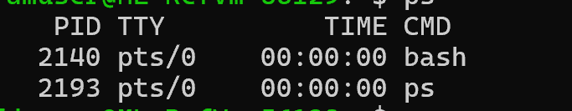  ps -eo pid=,comm= | grep -E '[[:space:]]bash$' | tr -s ' ' | cut -d' ' -f1
 | echo $$ | This is another way to get it more directly.  
 | kill $$ | - This command will not work.  - ‘kill’ is used to stop a process but your Bash session tries to protect itself.
 | kill -9 $$ | What does the option ‘-9’ do?  It disconnects the server  Kills the shell instantly
 | Restart a new Bash session if you ran the last command.
 | sleep 3 | - Some tasks take time to complete.  - ‘sleep’ has other uses but in this case is just used to simulate a larger task.
 | sleep 100 & | - Tasks can be run in the background using ‘&’.  - Can you run other commands in the meantime?  Starts a backgroup job that sleeps for 100 seconds, a command that pauses for 100 seconds. & runs it in the backgroup returning immediately to the prompt.  Bash will print [1] 2329 as seen in the picture below, it can also be different.  [1] is job number. 2329 is PID of the backgroud process
 | ps; jobs | - Run both ‘ps’ and ‘jobs’ commands while sleep is running in the background.  - Check the output of the commands.  - ‘jobs’ is a useful shell abstraction of ‘ps’.  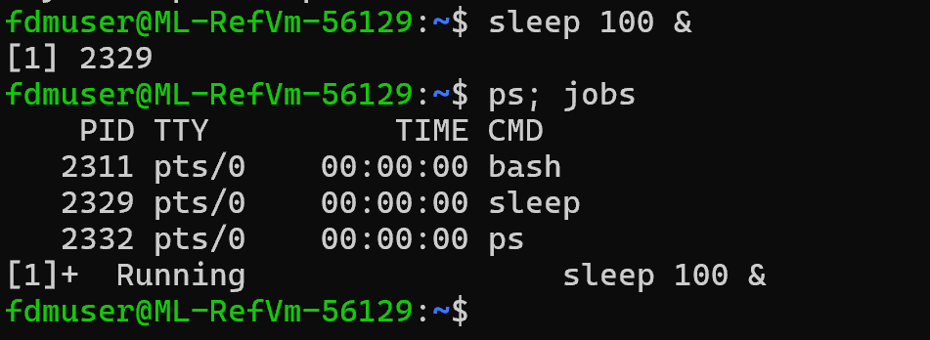  • 2311 → your current bash shell  • 2329 → the sleep 100 process you started  • 2332 → the ps command you just ran (it appears only for an instant)  • [1] → job number  • Running → state  • sleep 100 & → command that started the job
 | ps -ux  ps -efx | - Try different commands to understand what they do.  - What are the dependencies?  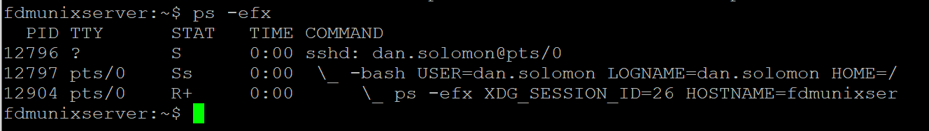  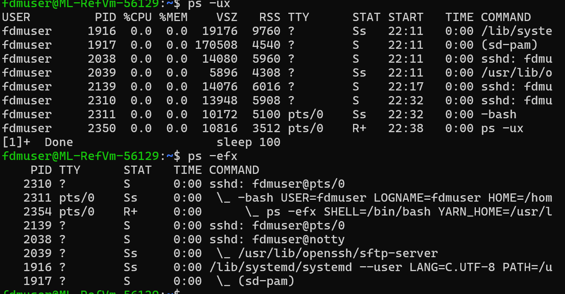  They both show workers just in different ways.  Ps -ux  - u = show detailed info about each worker  - x = include workers not sitting at a desk (background workers)  So ps -ux is like saying:  “Show me all the workers that belong to me, including ones not in front of a desk. Also show extra details about them.”  You can see bash, sleep, ssh session, ps command  Ps -efx  Breakdown:  - -e = show every worker in the whole building  - -f = show full details  - x = show workers not sitting at desks  So ps -efx is like saying:  “Show me every worker in the building, with full details, including the background workers.”  This includes:  - system workers  - security workers (systemd, sshd, etc.)  - your workers  - workers you didn’t start  - everything running on the whole machine  It’s the big picture view.  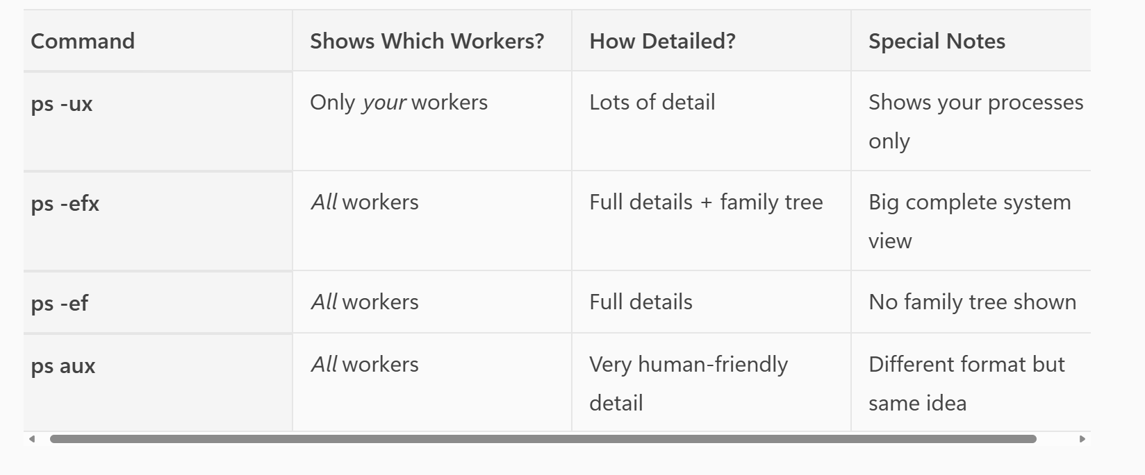
 | ps -ef  ps -aux | Try filtering the output using piping and other commands.  For example find your processes  • ps -ef = “Show all processes in full detail (official format).”  • ps aux = “Show all processes in a detailed, human-friendly format.”
What command lets you find all the Bash sessions running on the host?

ps -ef | grep bash

ps -ef | grep '[b]ash' – cleaner version

pgrep -a bash – cleaner version

Job management

- Processes can be managed by the owner or with permissions like from ‘sudo’.
- Operations include starting, pausing, restarting in background, and killing processes.

Activity

Try the following commands in a Bash session:

 | Command | Notes
 | sleep 1000 | Start a task
 | <CTRL><Z> | Pause foreground use the keys
 | ps | Notice that the processes running include bash, ps, and sleep
 | jobs | The job you might want to manage is just the ‘sleep 1000’
 | bg 1 | Restart task in background
 | fg 1 | Bring a Background Job to the Foreground
 | <CTRL><Z>  bg 1  kill %1 | Return job to background so it can be killed
- Kill a Background Job by PID

sleep 10000 &
ps aux | grep sleep
kill <PID>
ps

Other useful commands to research

- Modern Unix administration is done via consoles with graphical user interfaces found on modern Unix like operating systems.
- Batch processing still uses batch-style commands that can be scripted.

Activity

Research these commands and their uses:

wait

pauses the shell script until a background process finishes
sleep 5 &
echo "Waiting..."
wait
echo "Done"

Nohup
nohup runs a command so it continues running even after you log out or close the terminal.

Normally, when you close your terminal:
- The shell sends a SIGHUP (hangup signal)
- Background jobs are terminated
nohup prevents that.

nohup python script.py &

Final Exercise

Create a Bash script pair and log activity

- Bash scripts can also work together for different reasons.
- Scripts can monitor other jobs via system information and saved data in files or variables
- Logging uses a separate text file that can be read later to see what happened.

Activity

- This exercise involves creating two Bash scripts, `counter.sh` and `watcher.sh`, which interact with each other through a file (`shared_counter`).
- The goal is to increment the counter to a specific value and handle control flow between the scripts.
- Test the scripts together to verify proper interaction and termination.

Create `counter.sh` in the current directory
Nano counter.sh
#!/bin/bash
# Create counter file if it doesn't exist
echo "counter.sh initialised shared counter to 0"
echo 0 > /tmp/shared_counter
while true; do
echo "counter.sh setting count variable in shared counter"
count=$(cat /tmp/shared_counter)
echo "counter incrementing shared counter"
echo $((count + 1)) > /tmp/shared_counter
sleep 5
done

• CTRL + O → writes the file
• Enter → confirms the name
• CTRL + X → exit nano

make the script executable:
chmod +x counter.sh

Run the script:
./counter.sh
``
The script creates a number and keeps counting up by one every 5 seconds forever.

Create ‘watcher.sh’ in the current directory

#!/bin/bash
while true; do
echo "watcher.sh is saving pid of counter"
pid=$(ps | grep '[c]ounter.sh' | cut -d' ' -f1)
echo "pid of counter is $pid"
count=$(cat /tmp/shared_counter 2>/dev/null)
echo "watcher set count to $count"
if [[ $count -gt 5 ]]; then
echo "count is greater than 5"
echo "watcher resetting counter to 0 (was $count)"
echo 0 > /tmp/shared_counter
echo "watcher killing pid $pid"
kill "$pid"
echo "watcher restarting counter.sh"
counter.sh &
fi
sleep 2
done
watcher.sh keeps an eye on counter.sh by checking its process ID and reading the shared counter value.
If the counter goes above 5, it resets the number back to 0, stops counter.sh, and then starts it again.

Use chmod to make both shell scripts executable

HELP
Run the counter.sh script first in the background, then start watcher.sh:

./counter.sh &
./watcher.sh

HELP
Can you add logging to these scripts so they both use ‘tee’ to display the messages to the screen and append the messages to the same text file in the current directory?

HELP

Can you prepend a time stamp to each message logged?

From:
counter.sh started
To:
025-04-15 12:35:32 counter.sh started

HELP

End!

